Lab 2

Requirement: Apply your knowledge of coding structure and Clean Code principles to build a device management software using .NET Core MVC with the following functionalities:

Github link:

Create 3 class in Controller

1.CategoriesController

2. DeviceController

3. UserController

Create 3 class in Model

1. Category

2. Device

3. User

Then create List of Item for each Categories with fucntion Display list , add , delete,edit.  
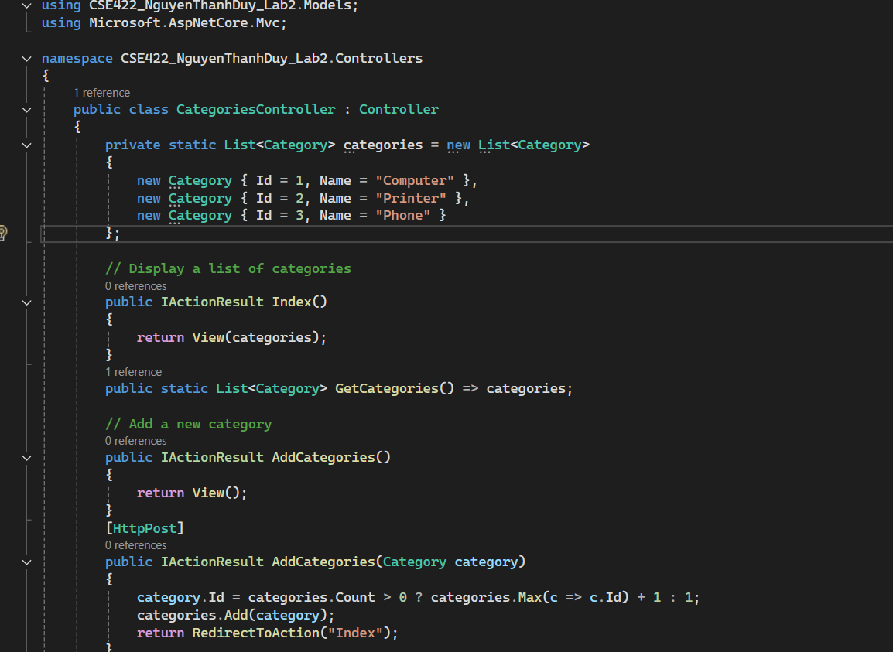

Then create List of Item for each Device with fucntion Display list , add , delete,edit.

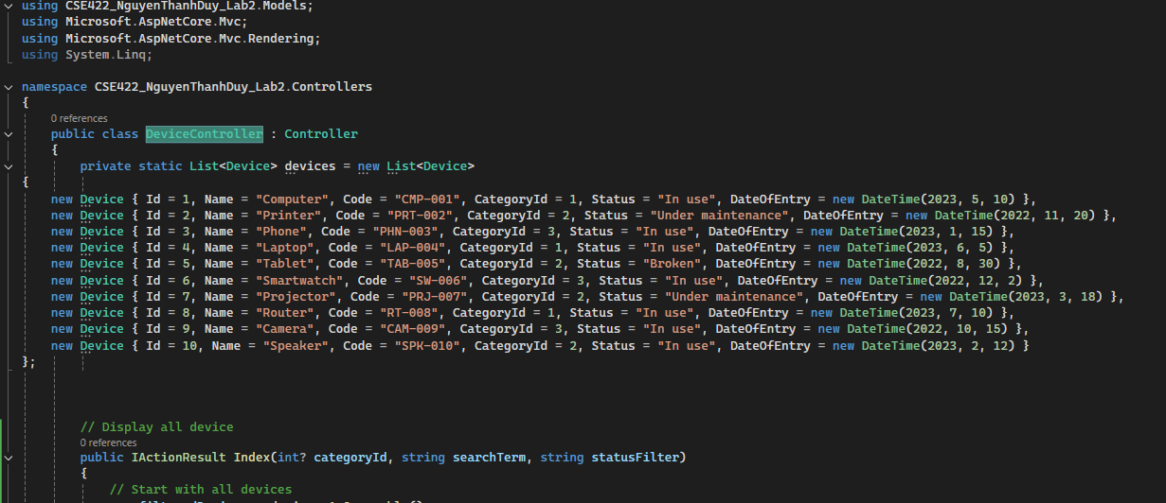

Then create List of Item for each User with fucntion Display list , add , delete,edit.

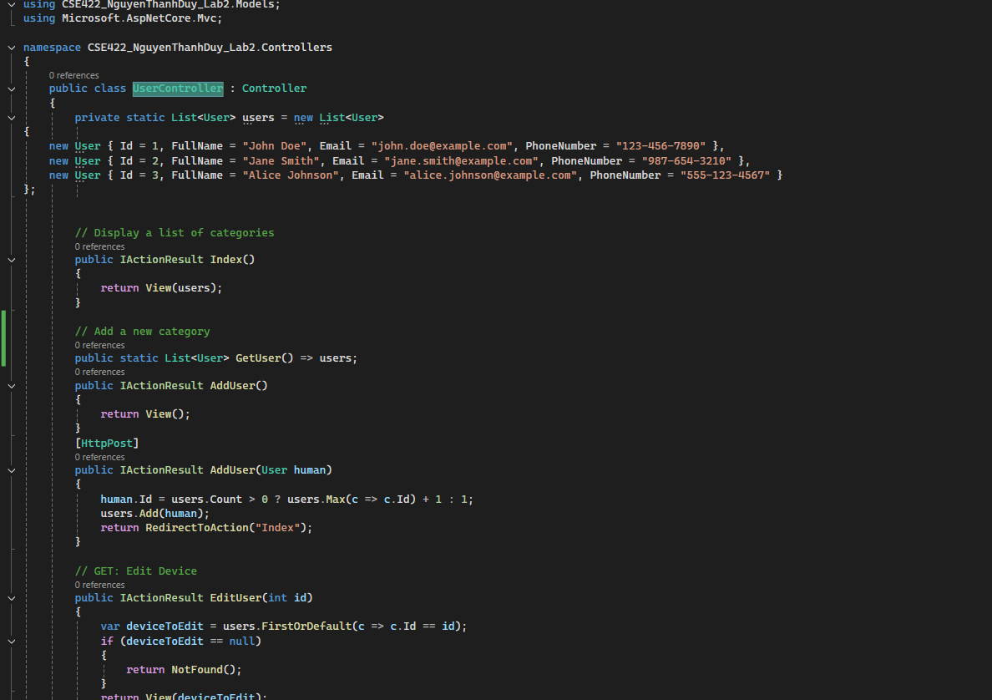

Create View for Category   
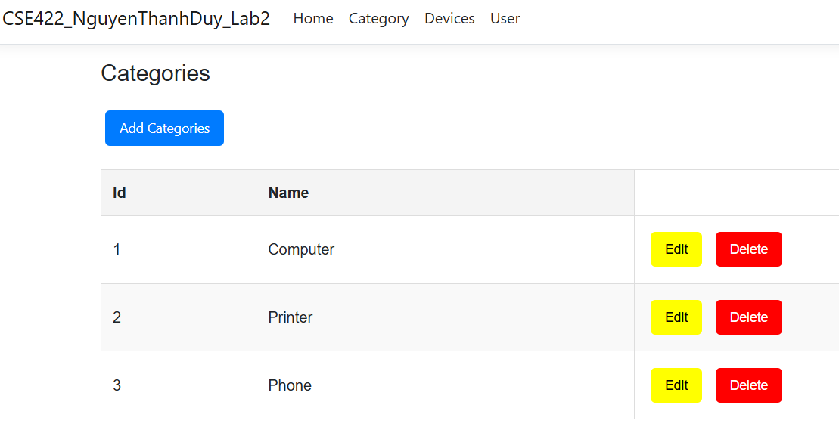

Add Categories   
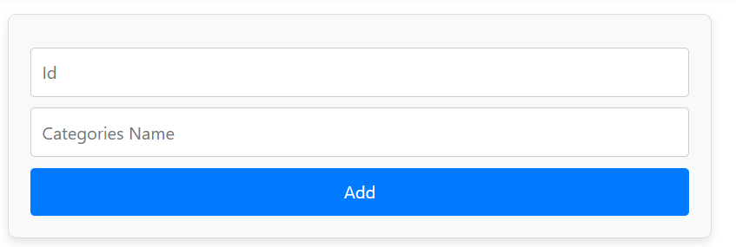

Edit Categories

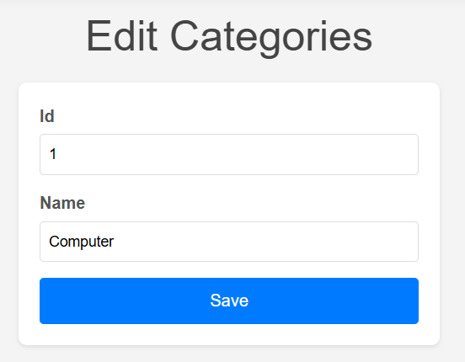

Delete Categories:

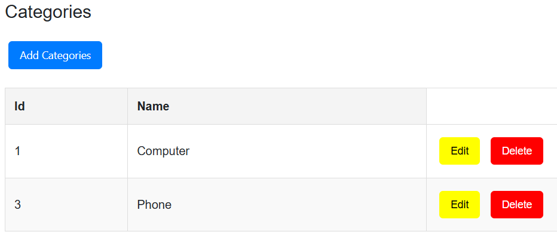

Create View for Device

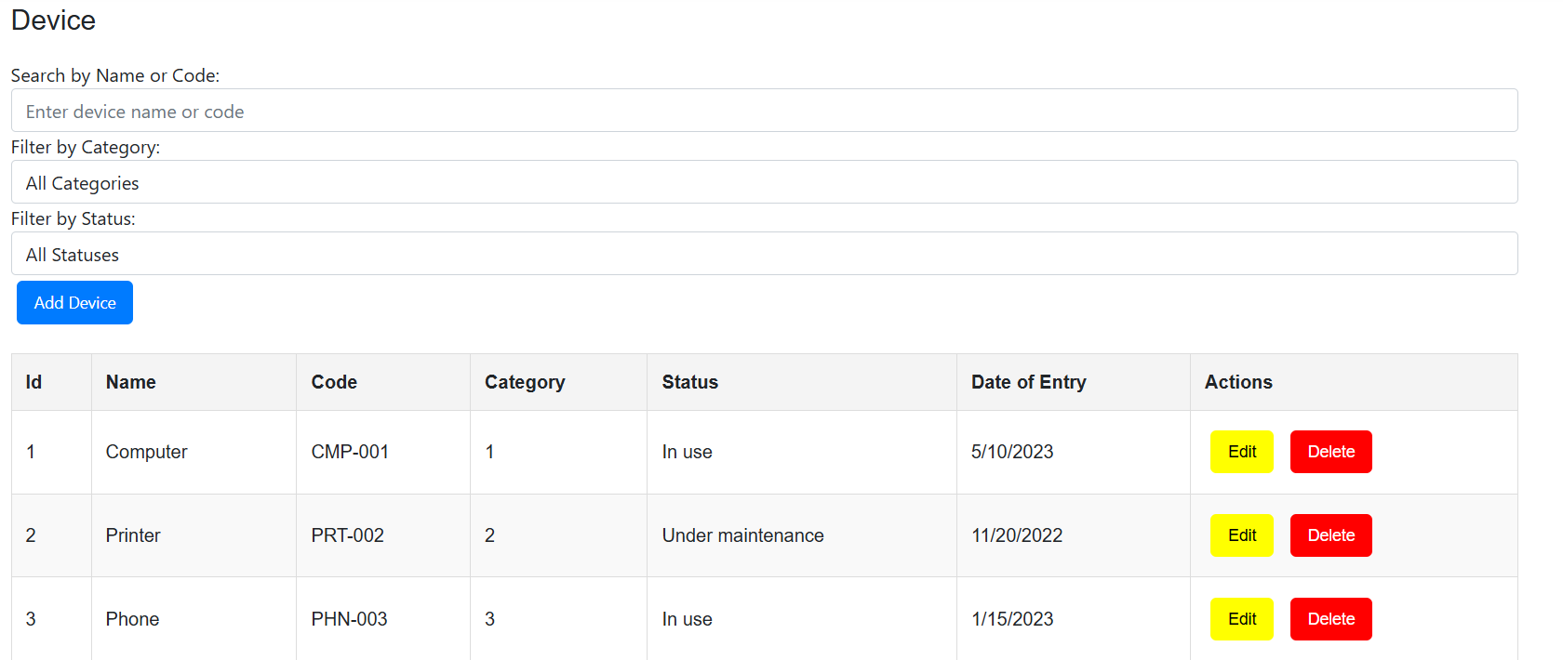

Add Device  
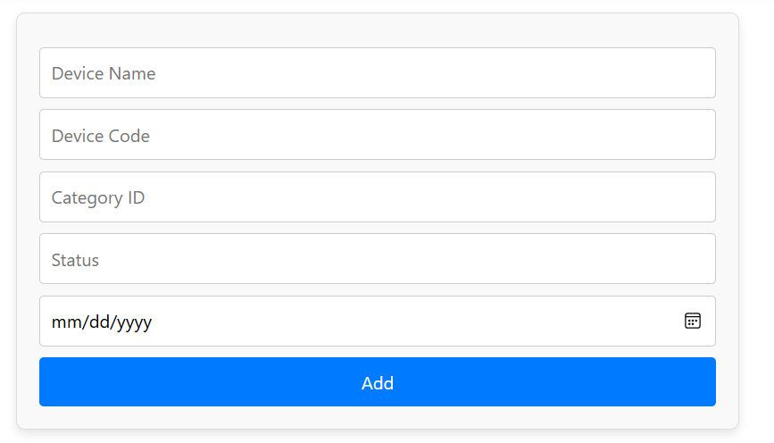

Edit Device

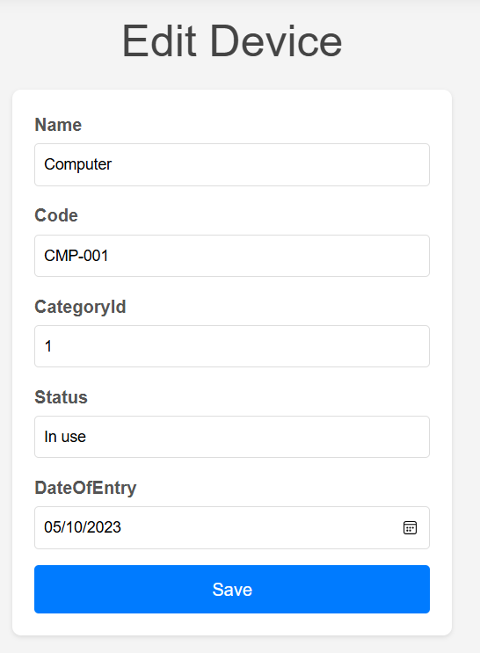

Detele Device

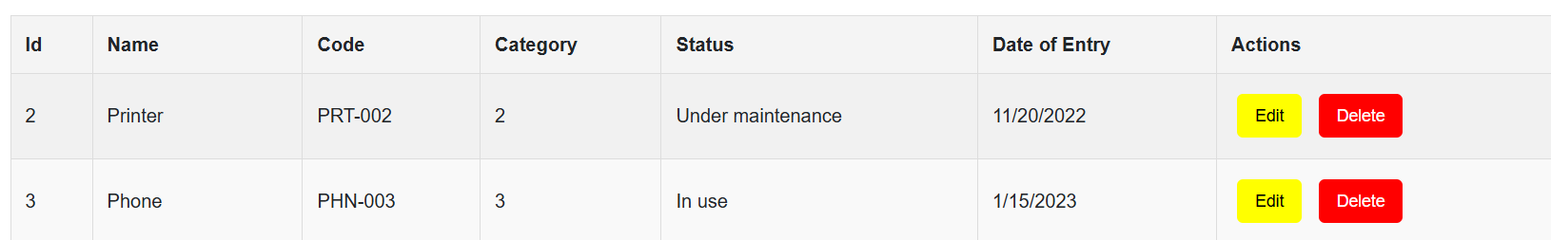

Search by Name or Code in Device :

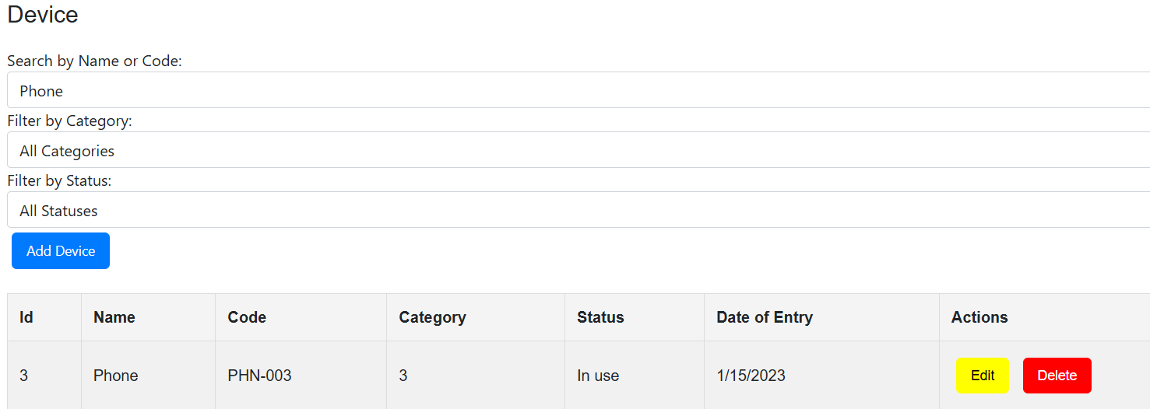

Filter by Category in Device :

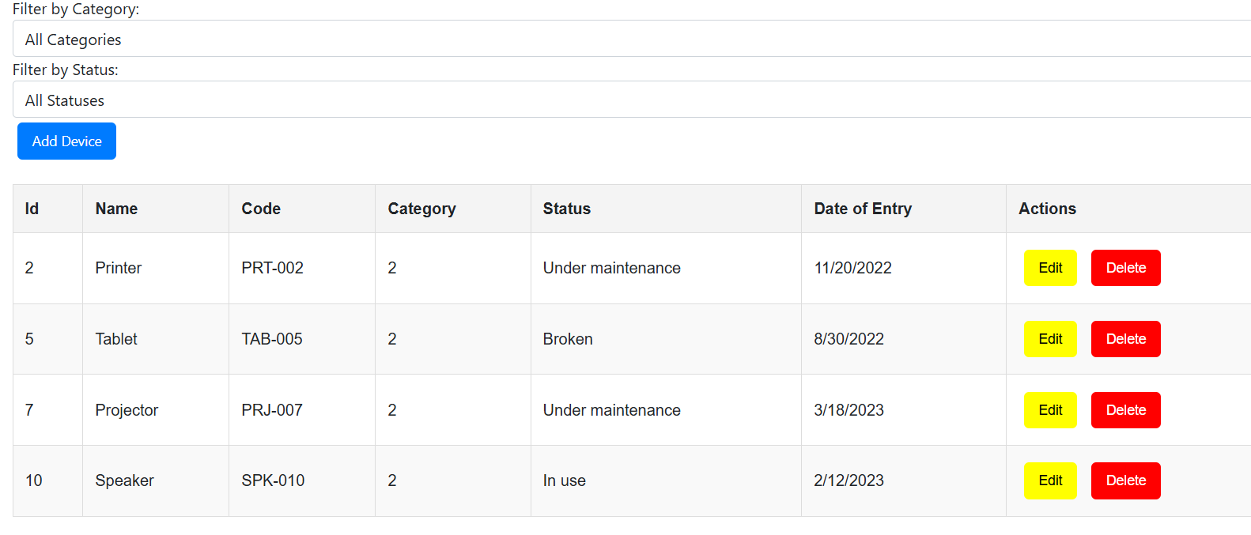

Filter by Status in Device :

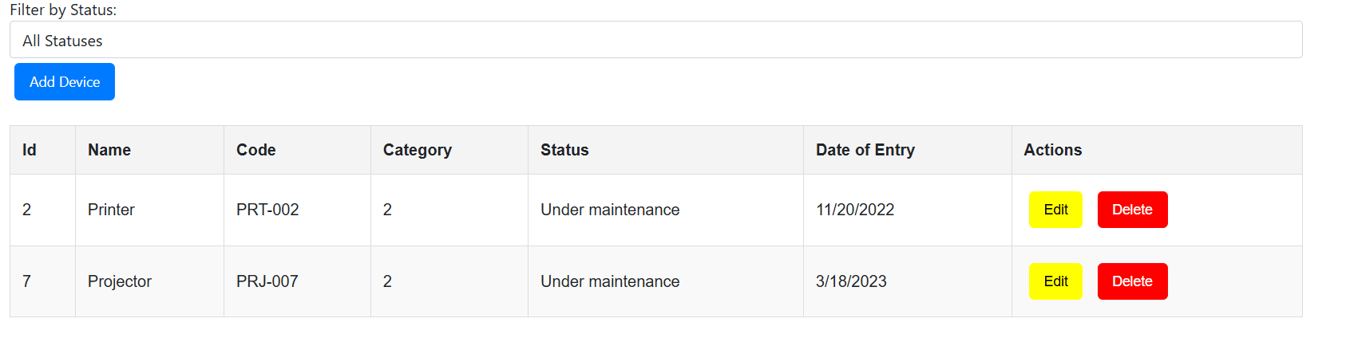

Create View for User:

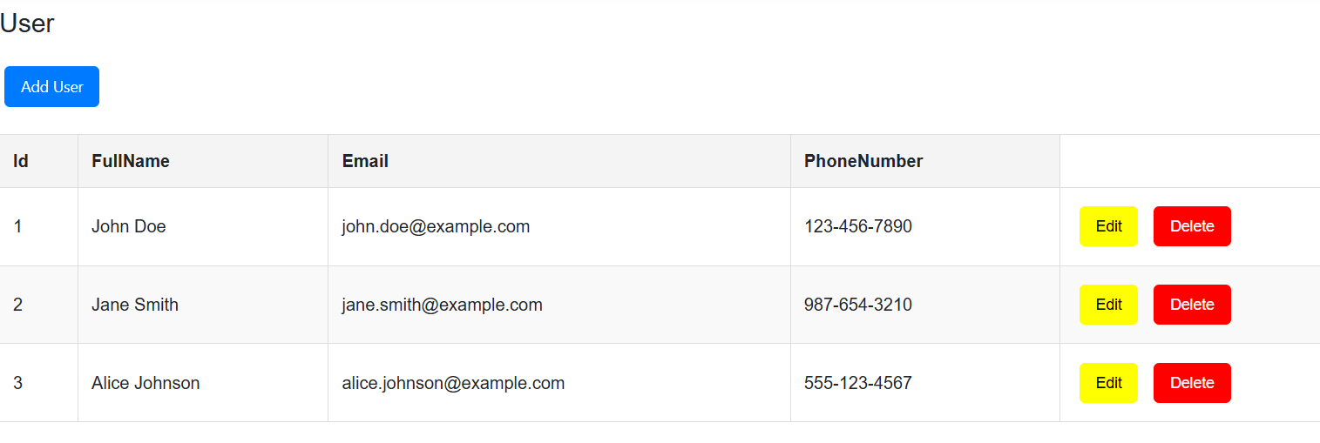

Add User  
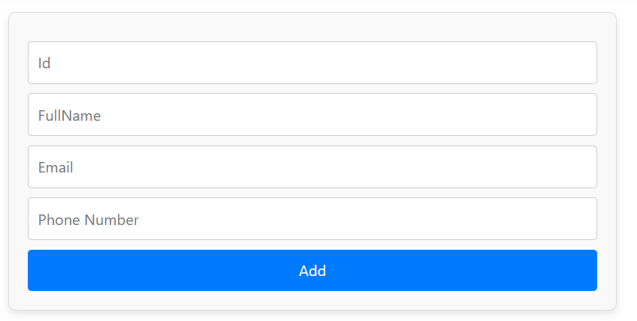

Edit User

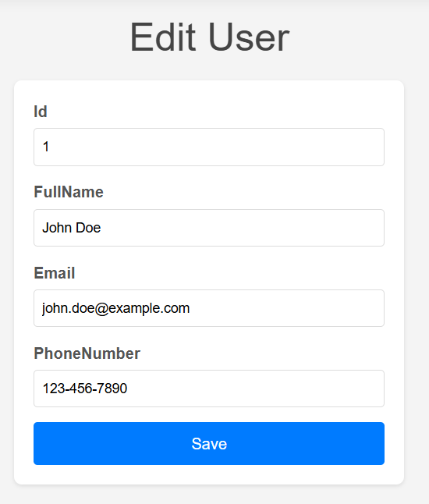

Delete User